These instructions are just if you want to manage your own spreadsheet and have more control over password/access refresh. If you just want to create a password protected file/folder with either no or weekly refresh, feel free to use either of the sheets I am hosting linked below:

No refresh: <https://docs.google.com/spreadsheets/d/1tXh2yCT78cEjgV9mNcHsdePXYk8lY1NBRbUEjkV0MeY/edit?usp=sharing>

Weekly refresh: <https://docs.google.com/spreadsheets/d/1BrnC64sIsVWw_X4vzLPQxFRW-P5u8RoLnKEjDj2sTD0/edit?usp=sharing>

**Step 1: Make a copy of the template sheet at the link below** [**https://docs.google.com/spreadsheets/d/1WdM_xt2s7hKfo2AKMuiHJ7qF-jlUuXYwR3QSJ2TgBxU/edit?usp=sharing**](https://docs.google.com/spreadsheets/d/1WdM_xt2s7hKfo2AKMuiHJ7qF-jlUuXYwR3QSJ2TgBxU/edit?usp=sharing)

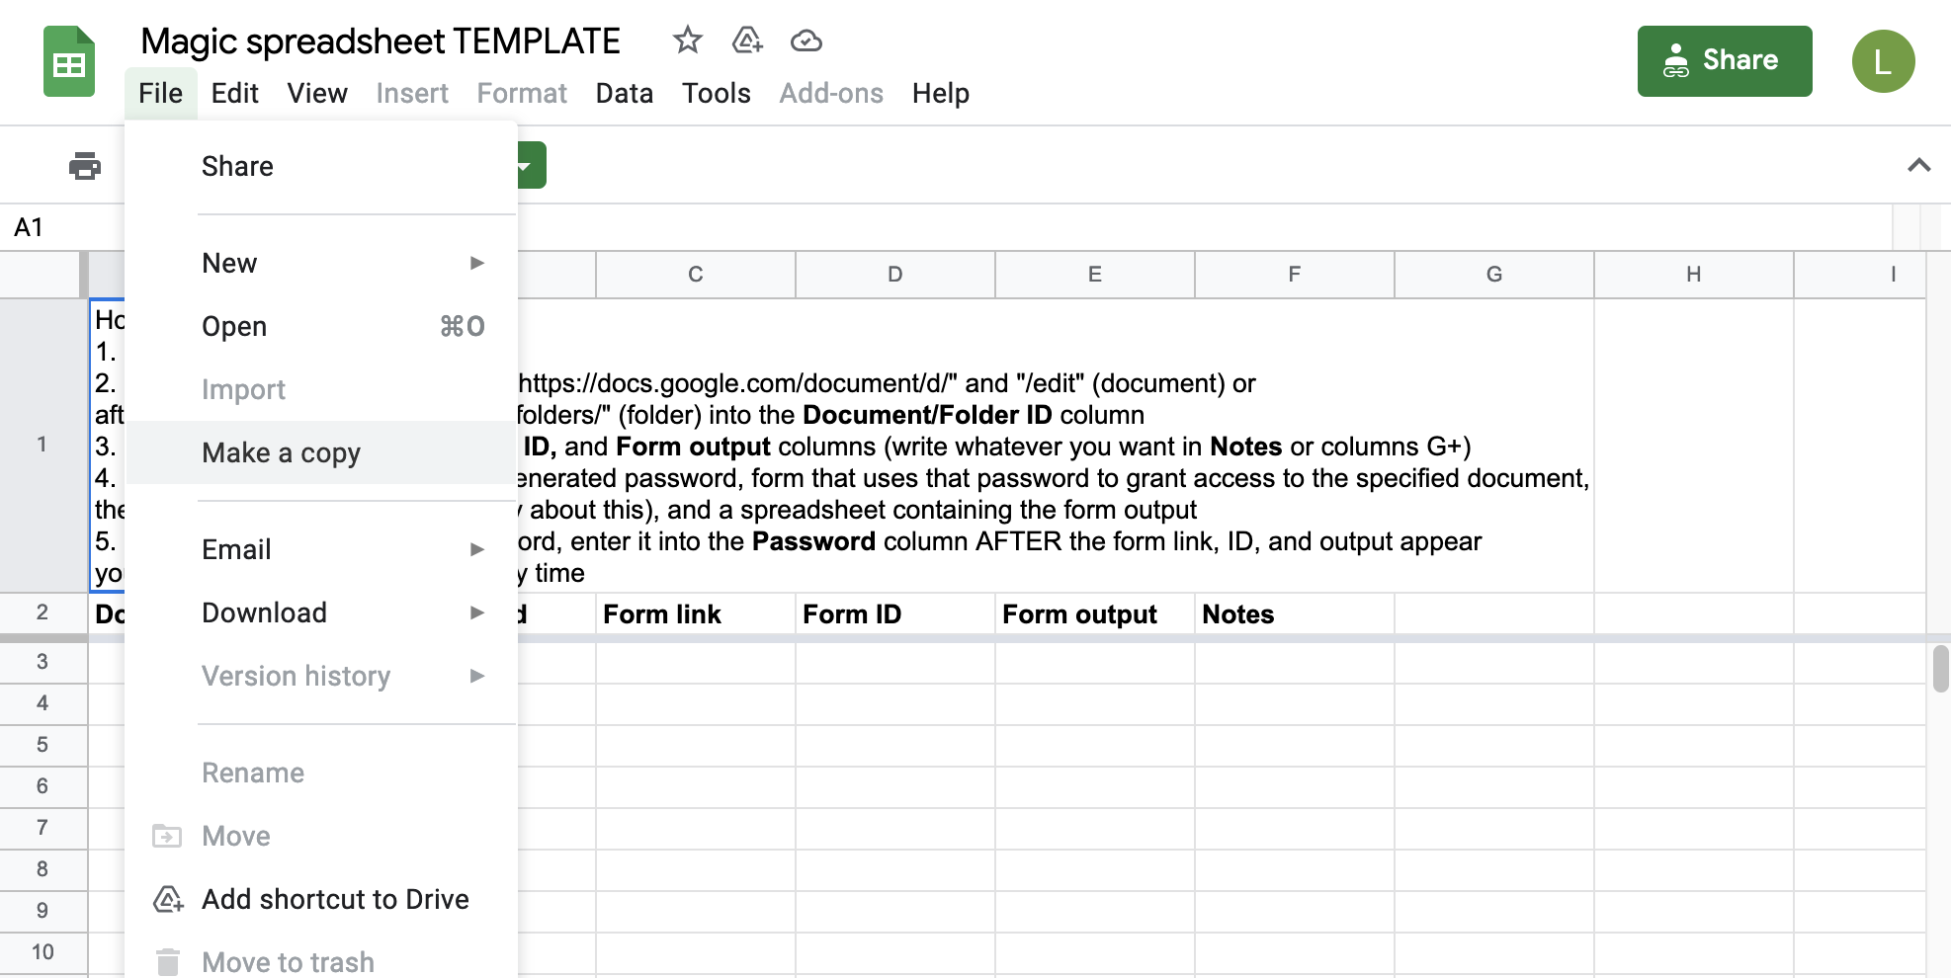

**Step 2: In your copy of the sheet, click on Tools -> script editor**

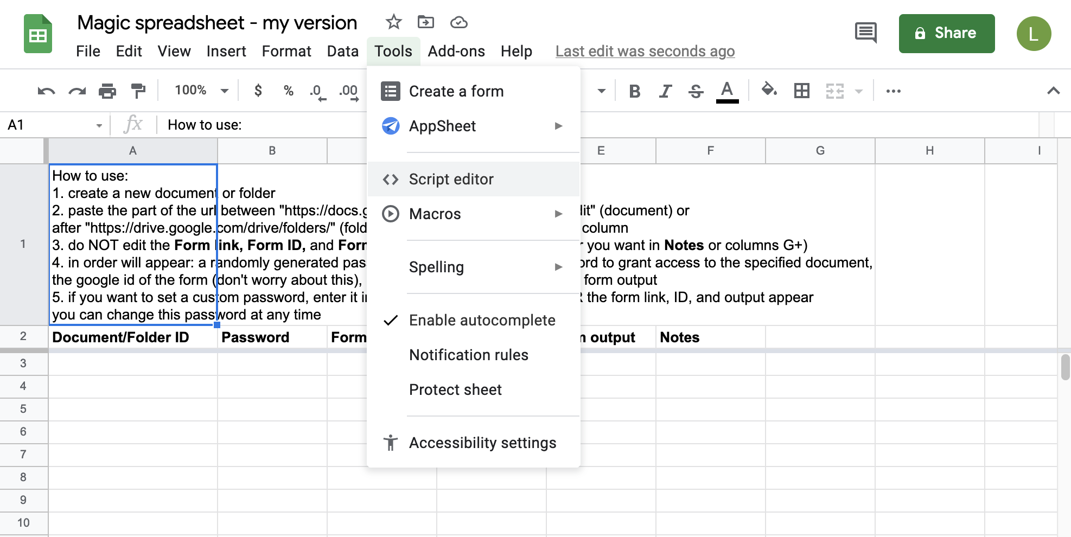

Sometimes Google Scripts does not open properly if you are not the only one logged in to Google on that browser, log out of all other Google accounts if you are having issues.

You should see a screen that looks like this, feel free to rename the project at the top however you want.

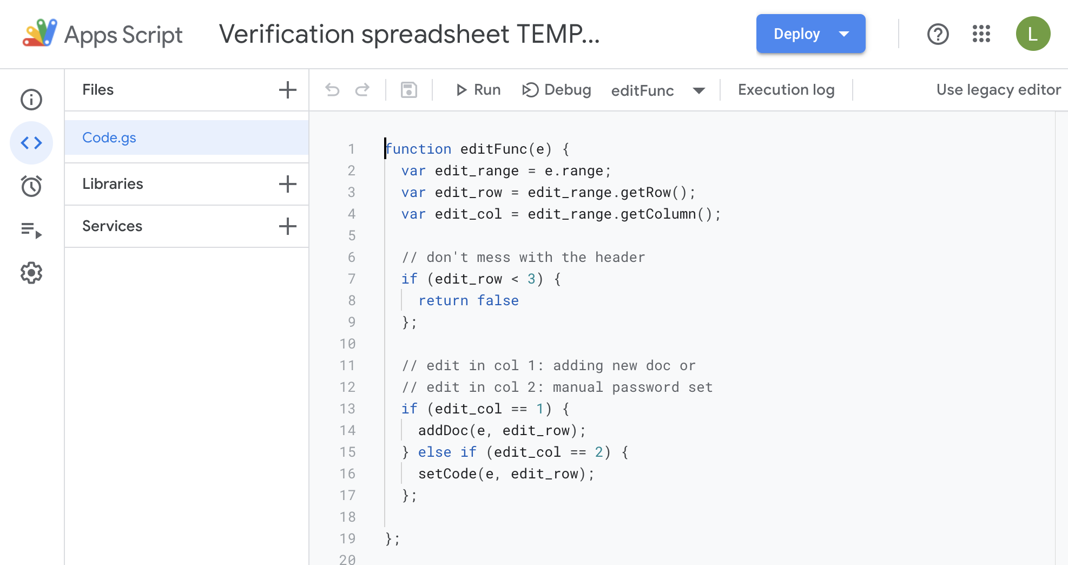

**Step 3: Set up the edit trigger for the spreadsheet**

Click on Triggers (clock icon) -> Add trigger (bottom right)

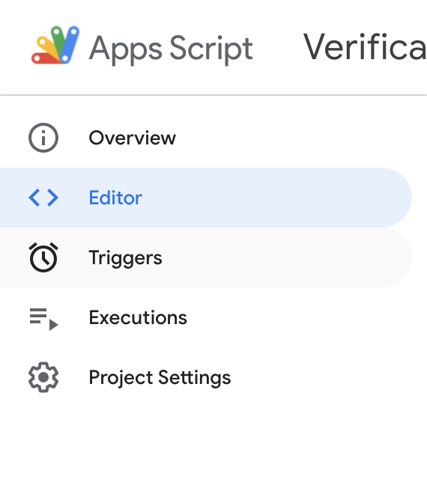 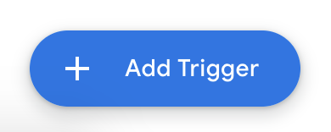

Make sure the settings match the ones below and click Save (you may have to scroll down to see the save button)

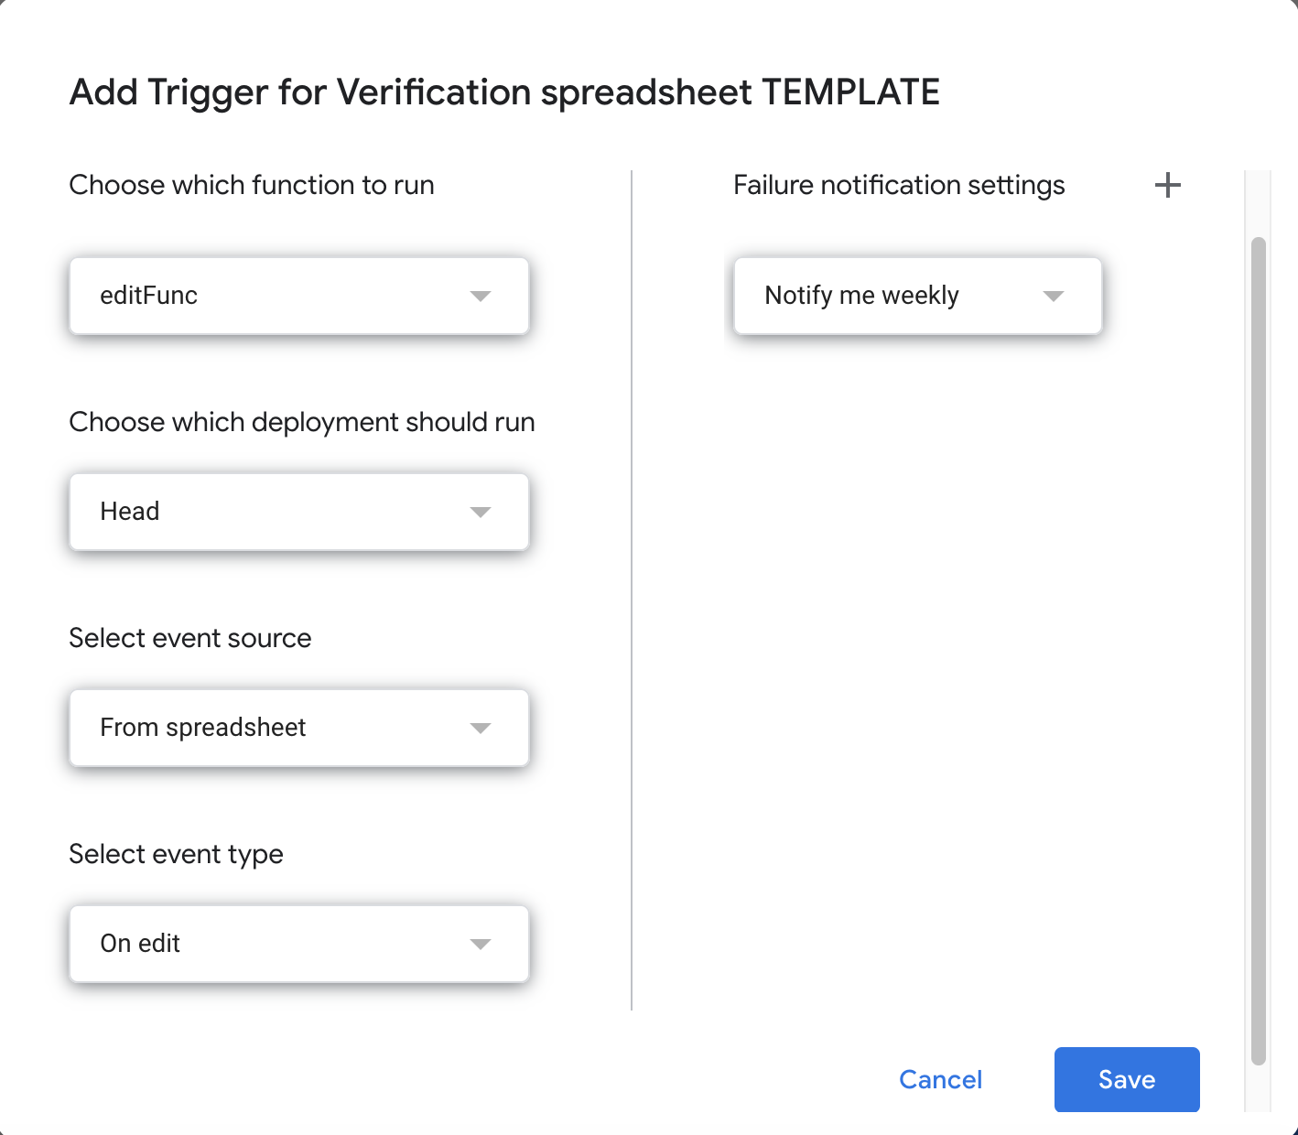

Google will ask you to sign in and grant the app permission to access sensitive info. Click Advanced -> Go to [whatever you named the project] (unsafe) and grant it the permissions it requests.

Now you should be able to use your spreadsheet to generate password forms for whatever document/folder you want! (If it doesn’t work immediately, make sure to reload the spreadsheet first. You can share the spreadsheet to allow other people to use it, but they will have to share documents/folders with *your* Google account, as you are now the script owner)

**Step 4 (optional): Set up a timed trigger to refresh access (remove viewers from documents/folders, create new random passwords)**

Go to Triggers -> Add Trigger

Make sure the “Choose which deployment to run” and “Select event source” options match the ones below. Under “Choose which function to run”, select “timedFullRefresh” to remove viewers AND change all passwords to new random passwords or “timedRefreshAccess” to remove all viewers without changing any passwords.

Note that this will affect ALL documents/folders in the spreadsheet.

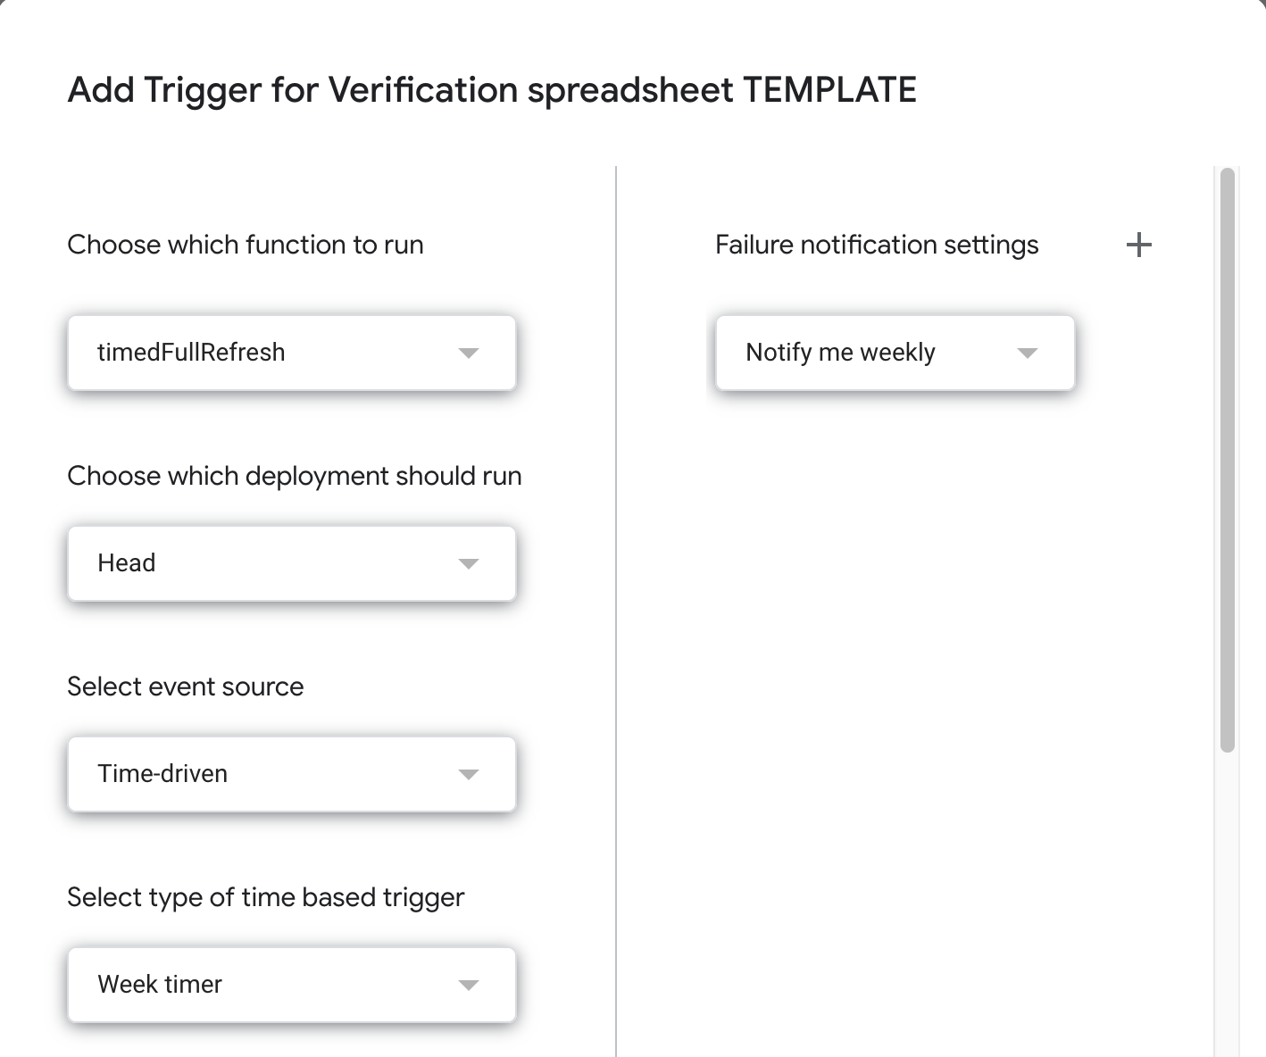

Use the “Select type of time based trigger” and other options to specify when and how often you would like the refresh to run.

**Step 5 (optional): Manually refresh access**

It is also possible to manually remove all viewers and create new random passwords or just manually remove all viewers if you need to for whatever reason.

Note that this will affect ALL documents/folders in the spreadsheet.

Click on Editor (<> icon)

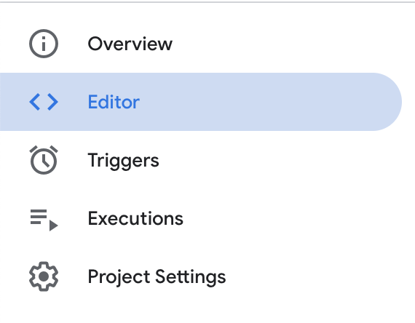

In the top menu, select “fullRefresh” (remove and create new passwords) or “refreshAccess” (just remove viewers) from the dropdown and click Run.

